Streamlining Tickets Assignment For Efficient Support Operations
INTRODUCTION
The project “Streamlining Ticket Assignment for Efficient Support Operations” focuses on improving the way support tickets are managed and assigned. In many organizations, handling a large number of tickets manually leads to delays, errors, and inefficient use of resources. This project aims to develop a structured and automated system for assigning tickets based on priority, type, and team availability. By reducing manual intervention, it helps in faster response and resolution times. The system also enhances transparency and tracking of support requests. Efficient ticket assignment ensures better workload distribution among support staff. Overall, this project improves productivity and customer satisfaction by making support operations more organized and effective.

PROCESS:
STEPS TO CREATE USERS:
1.Open service now.
2.Click on All >> search for users
3.Select Users under system security
4.Click on new
5.Fill the following details to create a new user
6.Click on submit.

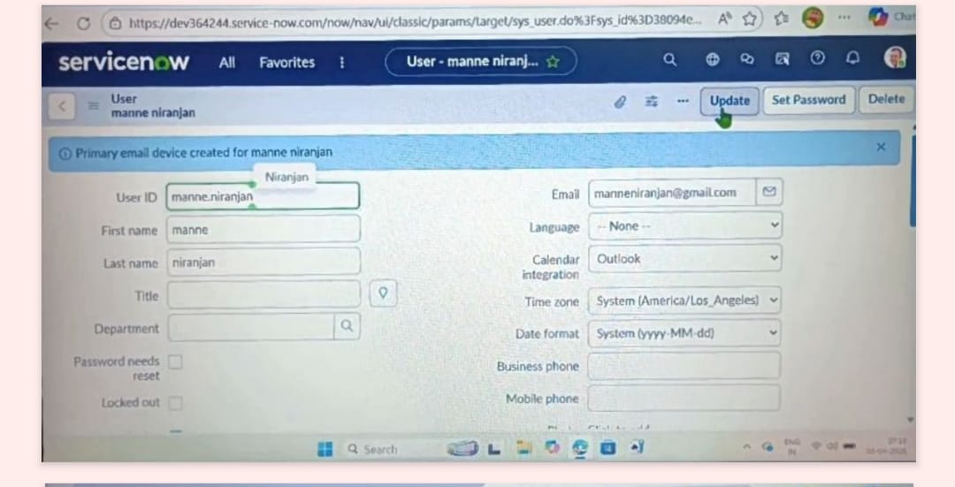

7.Create another user with the following details
8.Click on submit

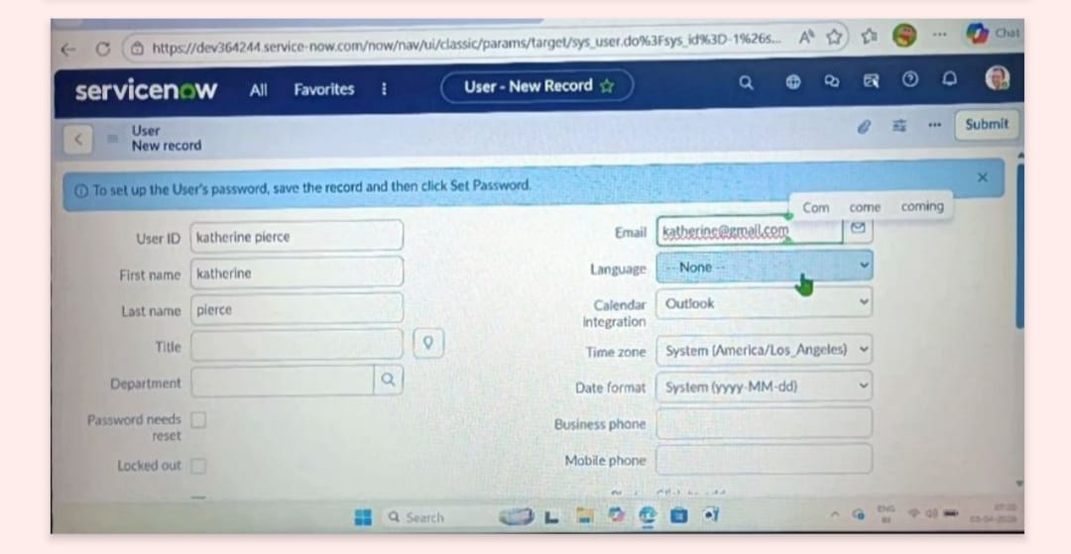
STEPS TODA CREATE GROUPS:
1.Open service now.
2.Click on All >> search for groups
3.Select groups under system security
4.Click on new
5.Fill the following details to create a new group
6.Click on submit

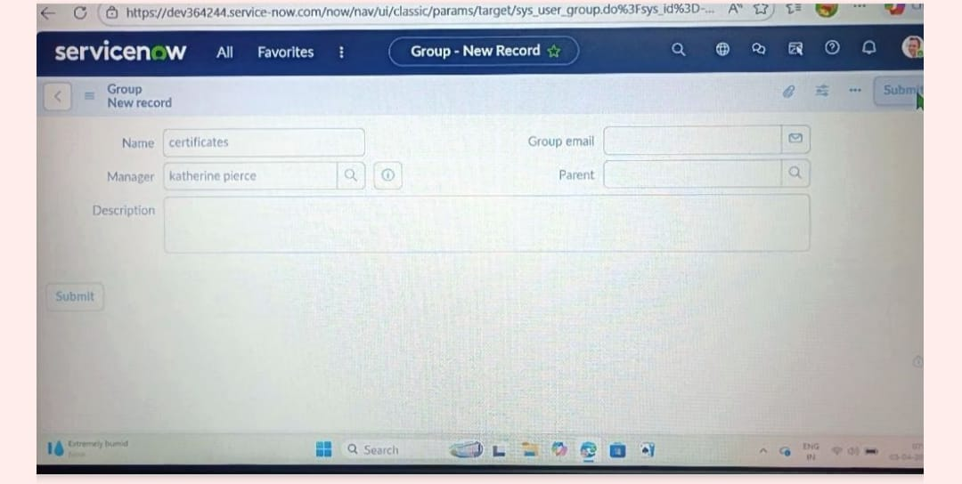
1.Create another group with the following details
2.Click on submit

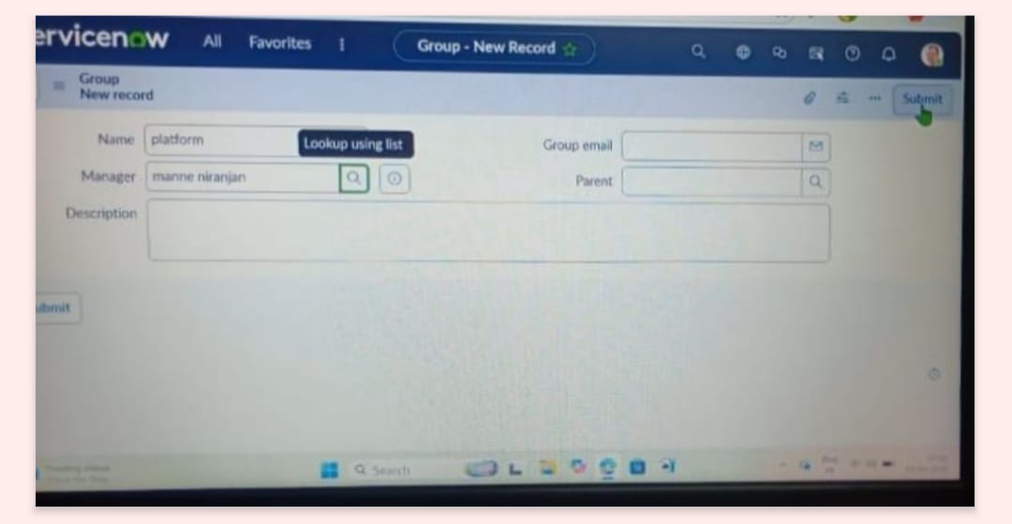

CREATE ROLES:

1.Open service now.
2.Click on All >> search for roles
3.Select roles under system security
4.Click on new
5. Fill the following details to create a new role
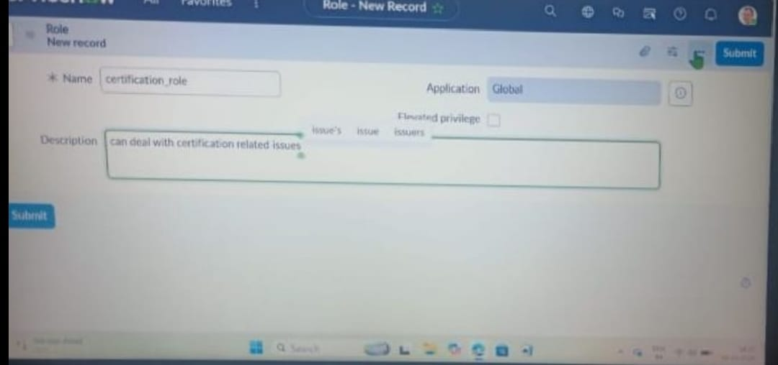
6.Click on submit
CREATE ONE MORE ROLE:
1.Create another role with the following details

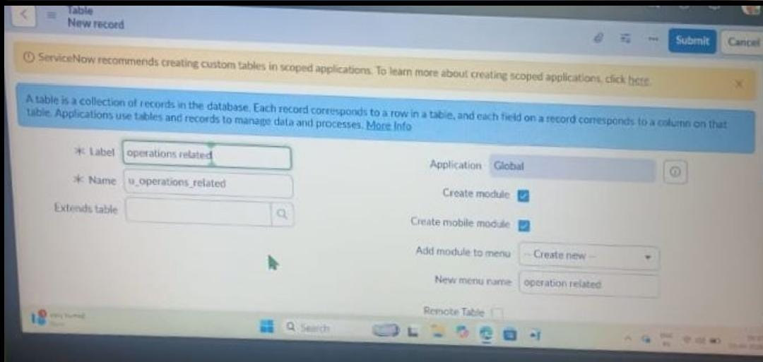
2.Click on submit
1.Open service now.
2.Click on All >> search for tables
3.Select tables under system definition
4.Click on new
5.Fill the following details to create a new table
Label : Operations related
Check the boxes Create module & Create mobile module
6.Under new menu name : Operations related
7.Under table columns give the columns
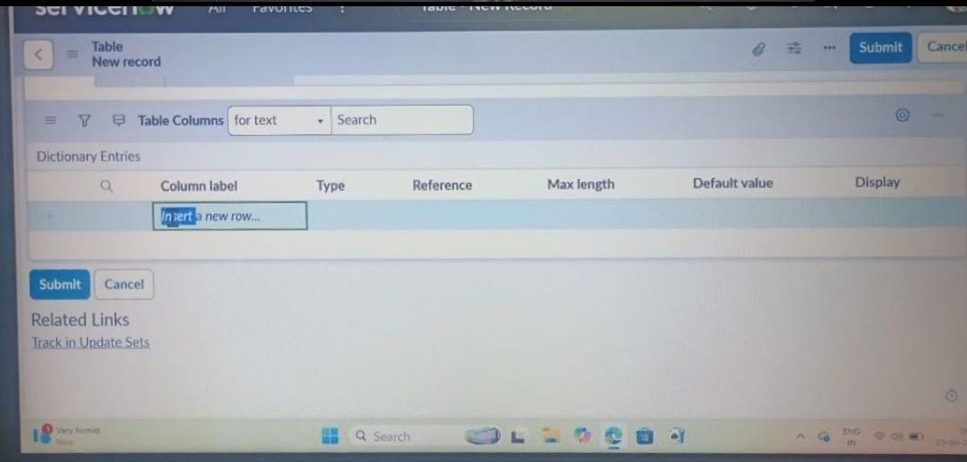
8.Click on submit
9.Create choices for the issue filed by using form design
Choices are
unable to login to platform
404 error
regarding certificates
regarding user expired

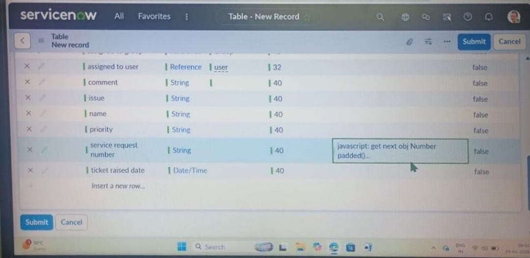
ASSIGN ROLES & USERS TO CERTIFICATE GROUP :
1.Open service now.
2.Click on All >> search for tables
3.Select tables under system definition
4.Select the certificates group
5.Under group members
6.Click on edit
7.Select Katherine Pierce and save
8.Click on roles
9.Select Certification_role and save

ASSIGN ROLES & USERS TO PLATFORM GROUP:
1.Open service now.
2.Click on All >> search for tables
3.Select tables under system definition
4.Select the platform group
5.Under group members
6.Click on edit
7.Select Manne Niranjan and save
8.Click on roles
9.Select Platform_role and save

ASSIGN ROLE TO TABLE:
1.Open ServiceNow and navigate to All → System Definition → Tables.
2.Search and open the Operations Related table.
3.Click on Application Access.
4.Open the u_operations_related.read operation.
5.Click your profile (top right) and Elevate Role → security_admin.
7.Under Requires role, insert a new row and add:
1.Platform_role
2.Certification_role
8.Click Update.
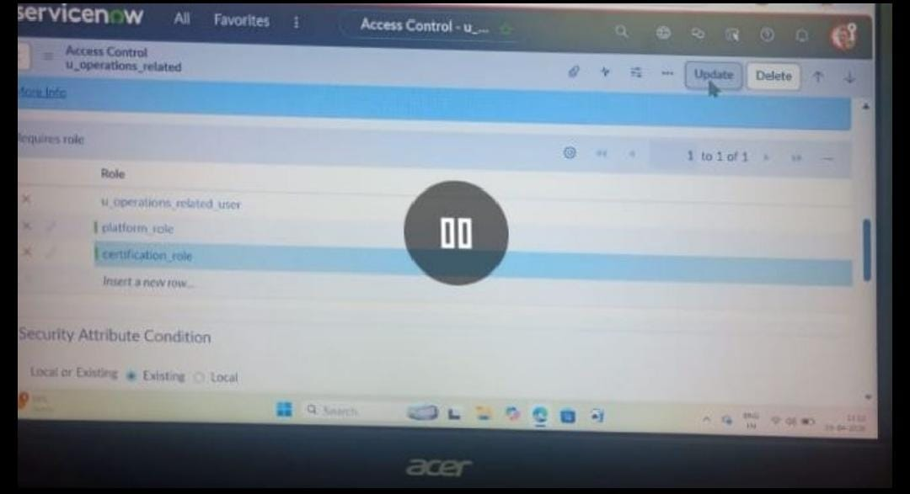
1.Open the u_operations_related.write operation.
2.Under Requires role, insert a new row and add:
1.Platform_role
2.Certification_role
3.Click Update.
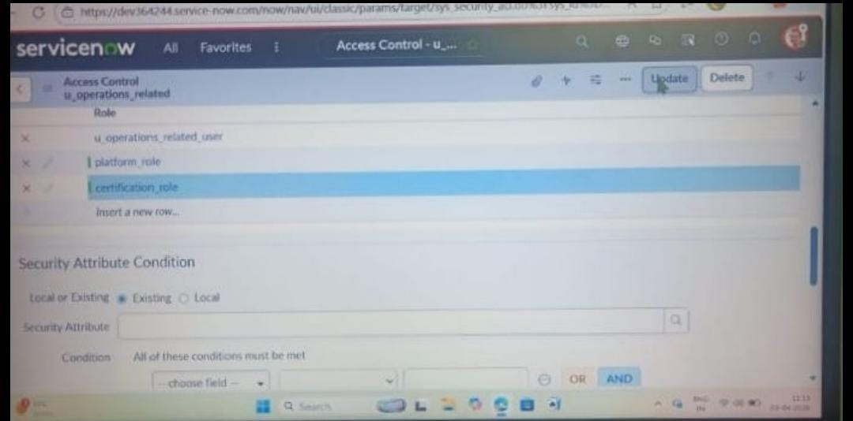

CREATE ACL:
1.Open service now.
2.Click on All >> search for ACL
3.Select Access Control(ACL) under system security
4.Click on new
5.Fill the following details to create a new ACL
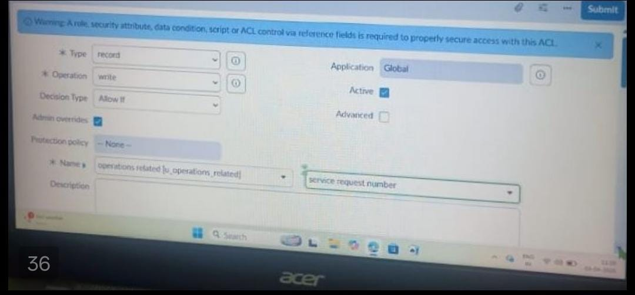
1.Scroll down under requires role
2.Double click on insert a new row
3.Give admin role
4.Click on submit
Similarly create 4 acl for the following fields
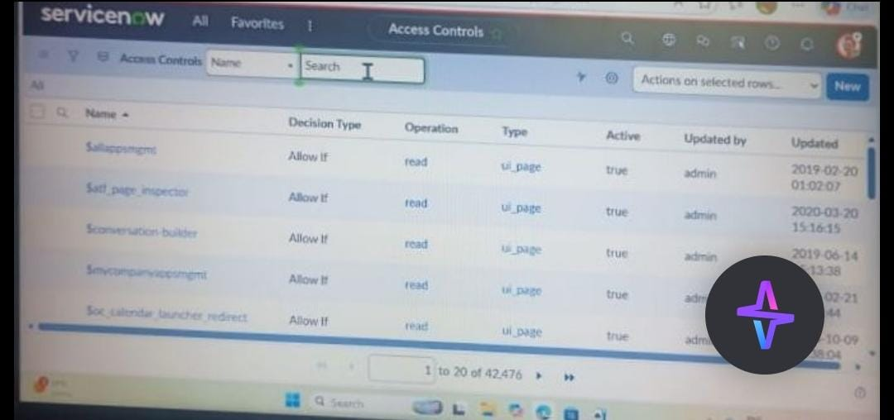

CREATE A FLOW TO ASSIGN OPERATIONS TICKET TO GROUP:
1.Open service now.
2.Click on All >> search for Flow Designer
3.Click on Flow Designer under Process Automation.
4.After opening Flow Designer Click on new and select Flow.
5.Under Flow properties Give Flow Name as “ Regarding Certificate”.
6.Application should be Global.
7.Select Run user as “ System user ” from that choice.
8.Click on Submit.

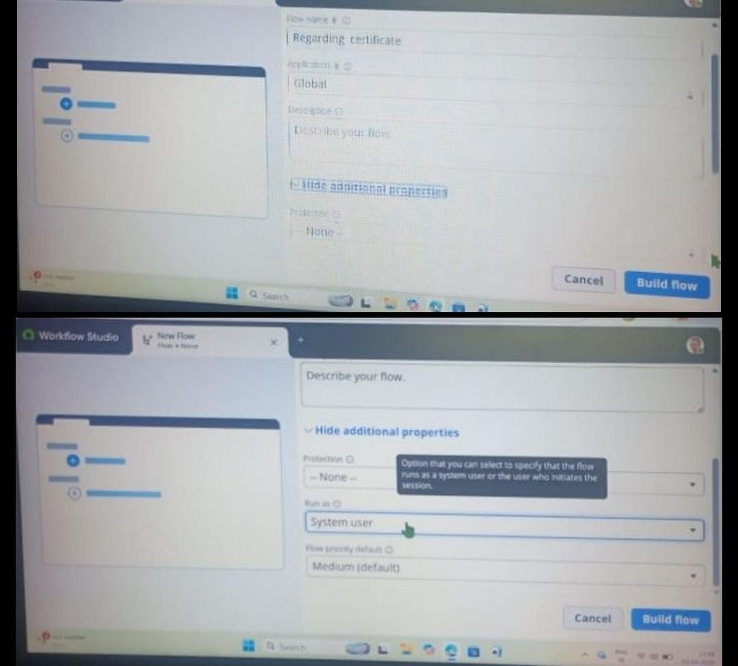
1.Click on Add a trigger
2.Select the trigger in that Search for “create or update a record” and select that.
3.Give the table name as “ Operations related ”.
4.Give the Condition as
Field : issue
Operator : is
Value : Regrading Certificates
5.After that click on Done.

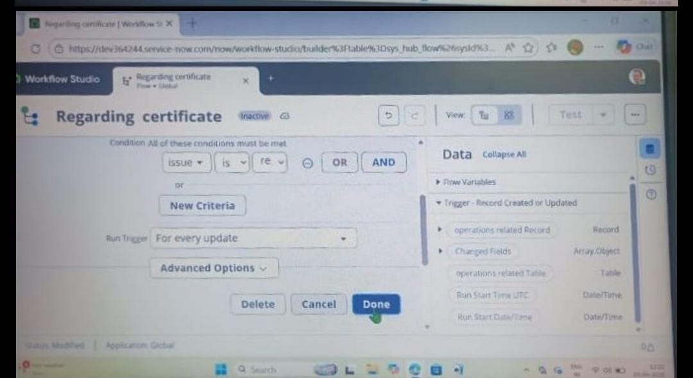

6.Now under Actions.
7.Click on Add an action.
8.Select action in that search for “ Update Record ”.
9.In Record field drag the fields from the data navigation from left side
10.Table will be auto assigned after that
11.Give the field as “ Assigned to group ”
12.Give value as “ Certificates ”
13.Click on Done.
14.Click on Save to save the Flow.
15.Click on Activate.
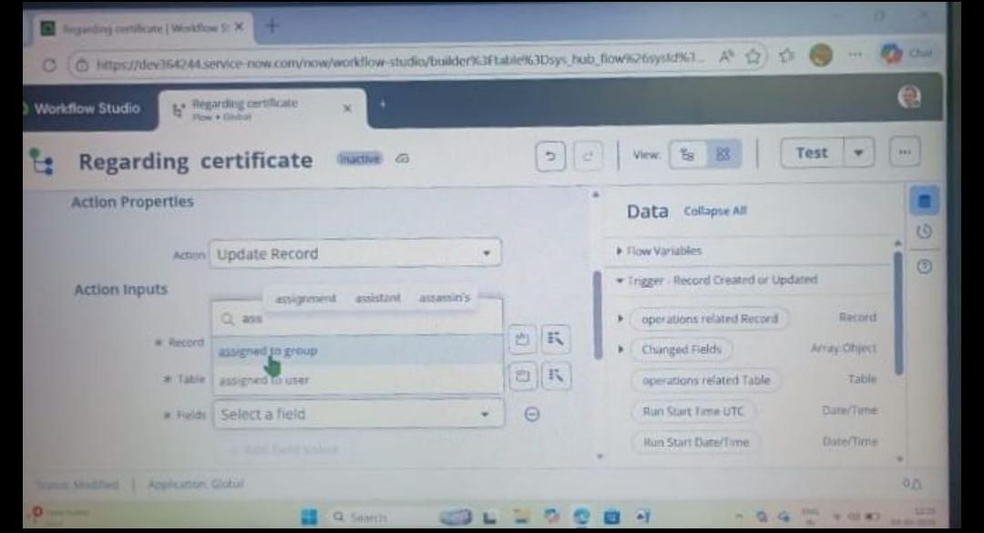

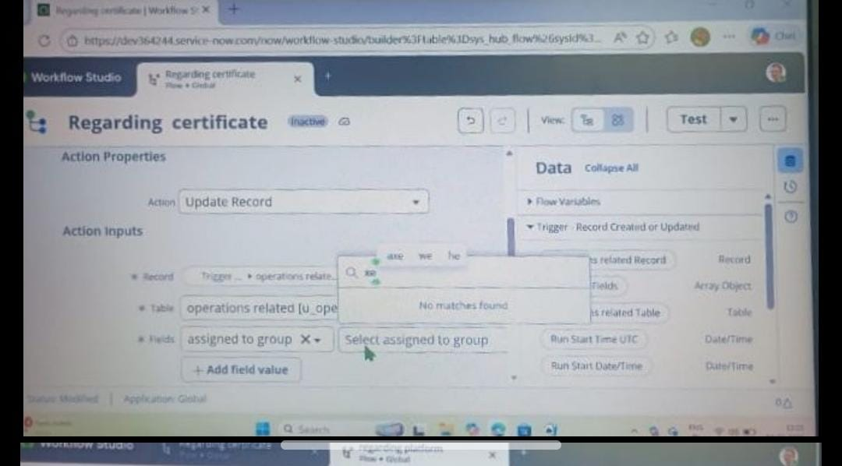

CREATE A FLOW TO ASSIGN OPERATIONS TICKET TO PLATFORM GROUP:
1.Open service now.
2.Click on All >> search for Flow Designer
3.Click on Flow Designer under Process Automation.
4.After opening Flow Designer Click on new and select Flow.
5.Under Flow properties Give Flow Name as “ Regarding Platform ”.
6.Application should be Global.
7.Select Run user as “ System user ” from that choice.
8.Click on Submit.
9.Click on Add a trigger
10.Select the trigger in that Search for “create or update a record” and select that.
11.Give the table name as “ Operations related ”.
12.Give the Condition as
Field : issue
Operator : is
Value : Unable to login to platform
5.Click on New Criteria
Field : issue
Operator : is
Value : 404 Error
6.Click on New Criteria
Field : issue
Operator : is
Value : Regrading User expired
7.After that click on Done.
8.Now under Actions.
9.Click on Add an action.
10.Select action in that search for “ Update Record ”.
11.In Record field drag the fields from the data navigation from left side
12.Table will be auto assigned after that
13.Give the field as “ Assigned to group ”.
14.Give value as “ Platform ”.
15.Click on Done.
16.Click on Save to save the Flow.
17.Click on Activate.

DESCRIPTION:
The implementation of the automated ticket routing system at ABC Corporation has significantly improved support operations by eliminating manual ticket assignment and reducing routing errors. Through structured configuration of groups, roles, access controls, and automated flows, tickets are now assigned instantly to the appropriate support teams based on predefined conditions.
This automation reduces reassignment delays, improves accountability, and ensures that issues are directed to the correct team from the start. By combining role-based security with workflow-driven routing, the solution enhances operational efficiency and supports faster, more reliable issue resolution across the organization.

